Module–4(Database)
- What is RDBMS
Relational Database Management System where data store in tables with relations.
- What is SQL
Structure Query Language used to manage database
- Write SQL Commands
CREATE, INSERT, UPDATE, DROP, DELETE, TRUNCATE, SELECT
- What is join?
Multiple tables ka data combine karna
- Write type of joins.
INNER JOIN
LEFT JOIN
RIGHT JOIN
FULL JOIN
SELF JOIN
- How Many constraint and describes it self
Constraint means rules applied on data
NOT NULL, UNIQUE, PRIMARY KEY, FOREIGN KEY, CHECK, DEFAULT
- Difference between RDBMS vs DBMS
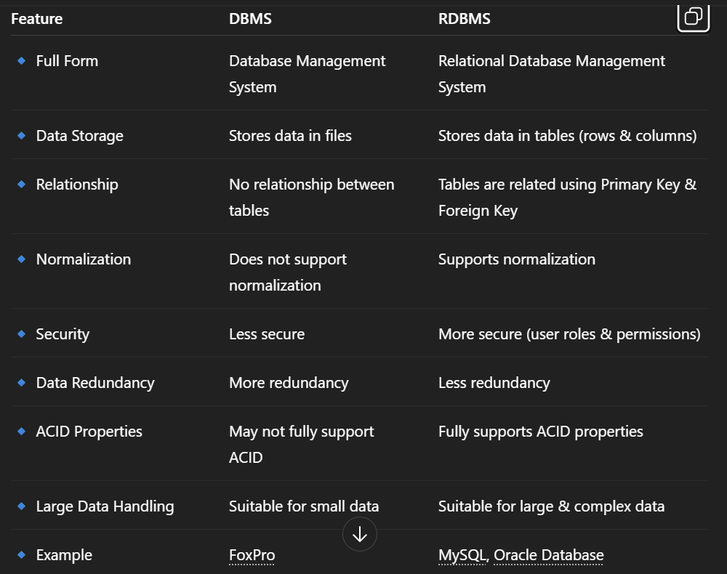
- What is an SQL alias?
Temporary Name

- Write a query to create the table in Structured Query Language.
CREATE TABLE table_name (
Column_name datatype constraints,
);
- Write a query to insert data into table.
INSERT INTO table_name (column1, column2, column3)
VALUES (value1, value2, value3);
- Write a query to update data into table with validations.
UPDATE table_name
SET column1 = value1,
column2 = value2
WHERE condition;
- Write a query to delete data from table with validations.
DELETE FROM table_name
WHERE condition;
- Write a query to insert new column in existing table.
ALTER TABLE table_name
ADD column_name datatype;
- Write a query to drop table and database.
EXAMPLE:
DROP TABLE Student;
- Write a query to find max and min value from table.
EXAMPLE:
SELECT
MAX(Salary) AS MaximumSalary,
MIN(Salary) AS MinimumSalary
FROM Employee;
- Create two tables named Seller and Product apply foreign key in product table Fetch data from both table using different joins.
Step 1: Create Seller Table
CREATE TABLE Seller (
SellerID INT PRIMARY KEY,
SellerName VARCHAR(50) NOT NULL,
City VARCHAR(50)
);
Step 2: Create Product Table (With Foreign Key)
CREATE TABLE Product (
ProductID INT PRIMARY KEY,
ProductName VARCHAR(50) NOT NULL,
Price DECIMAL(10,2),
SellerID INT,
FOREIGN KEY (SellerID) REFERENCES Seller(SellerID)
);
Step 3: Insert Sample Data
1.
INSERT INTO Seller VALUES
(1, 'Ramesh', 'Surat'),
(2, 'Suresh', 'Ahmedabad'),
(3, 'Mahesh', 'Mumbai');
2.
INSERT INTO Product VALUES
(101, 'Laptop', 50000, 1),
(102, 'Mobile', 20000, 1),
(103, 'Tablet', 15000, 2),
(104, 'Camera', 30000, NULL);
Step 4: Fetch Data Using Different Joins
1. INNER JOIN
SELECT Seller.SellerName, Product.ProductName, Product.Price
FROM Seller
INNER JOIN Product
ON Seller.SellerID = Product.SellerID;
2. LEFT JOIN
SELECT Seller.SellerName, Product.ProductName
FROM Seller
LEFT JOIN Product
ON Seller.SellerID = Product.SellerID;
3. RIGHT JOIN
SELECT Seller.SellerName, Product.ProductName
FROM Seller
RIGHT JOIN Product
ON Seller.SellerID = Product.SellerID;
4. FULL OUTER JOIN
SELECT Seller.SellerName, Product.ProductName
FROM Seller
FULL OUTER JOIN Product
ON Seller.SellerID = Product.SellerID;
- What is API Testing
API Testing is a type of software testing that verifies the functionality, reliability, performance, and security of an Application Programming Interface (API).
Instead of testing the UI (buttons, forms), API testing checks the backend logic and data exchange between systems.
- Types of API Testing
Types of API testing include Functional testing, Load testing, Security testing, Validation testing, Reliability testing, Negative testing, and Integration testing.
- What is Responsive Testing?
Responsive testing ensures that a website looks and works correctly on all screen sizes and devices.
- Which types of tools are available for Responsive Testing
Tools available for responsive testing include browser developer tools, online cloud platforms like BrowserStack and LambdaTest, automation tools like Selenium, and mobile emulators.
- What is the full form of .ipa, .apk
.APK stands for Android Package Kit and is used for Android apps
.IPA stands for iOS App Store Package and is used for iOS apps.
- How to create step for to open the developer option mode ON?
To enable Developer Options, go to Settings → About Phone → Tap Build Number 7 times → Go back to Settings → Open Developer Options and turn it ON.

